Colour Wheel Umbrella
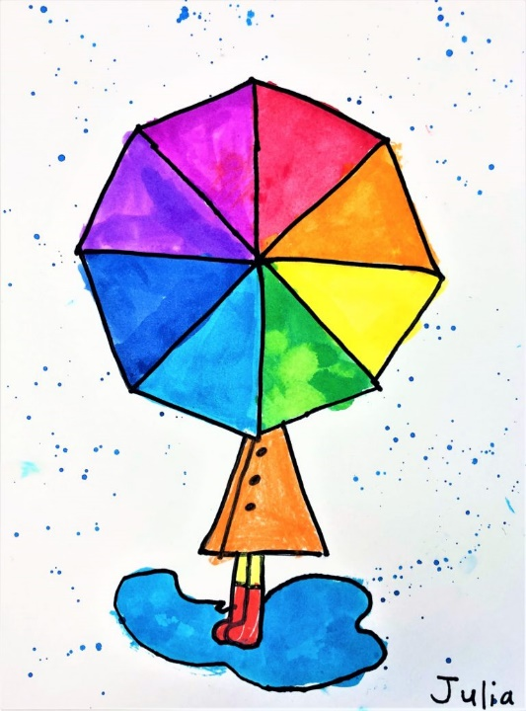
Materials
Red, blue and yellow paint (or pencil crayons/crayons)
Pencil/eraser
Paper
Instructions
Umbrella
Draw a big circle in the middle of the paper
Mark 6 dots at even intervals around the circle (parent help)
Connect the dots opposite to each other with a straight line, making the lines intersect
Raincoat
Draw a triangle shape coming out of the bottom of the circle – this is a raincoat
Draw boots at the bottom of the triangle
Draw a wavy circle shape around the raincoat and boots – this is a puddle
Add 3 little circles to the raincoat as buttons
Painting the Umbrella
Paint/colour the umbrella. Add red paint to one triangle, skip a space. Add yellow to the next triangle, skip a space. Add blue to the next triangle, leaving the next space blank.
Once you have painted on your primary colours, you are ready to do some mixing.
Mix red and yellow. What colour did you make? Add that colour to the space between red and yellow.
Mix yellow and blue. What colour did you make? Add that colour to the space between yellow and blue.
Mix blue and red. What colour did you make? Add that colour to the space between blue and red.
Complete your picture adding raindrops and colour to the boots/rain jacket!

Check for Understanding
What are the primary colours? (red, yellow, blue).
What are the secondary colours? (orange, green, purple).

